**Quantifying the global burden of bereavement due to Covid-19 using formal demographic models and demographic micro-simulation**

**Applicants**

PhD, Diego Alburez-Gutierrez, Max Planck Institute for Demographic Research (Lab of Digital and Computational Demography)

Prof. Dr. and Director, Emilio Zagheni, Max Planck Institute for Demographic Research (Lab of Digital and Computational Demography)

**Keywords**

demography, bereavement, family support, excess mortality, methodology

**In a Nutshell**

Much attention has been given to Covid-19 excess mortality rates, but little is known about how the pandemic will increase the exposure to the death of relatives (parents, grandparents, siblings, etc.) for people around the world. This project will produce the first dataset of excess bereavement attributable to the Covid-19 disease. It is the first attempt to quantify this phenomenon and its wide-ranging implications for society using a set of innovative methods from mathematical demography and computational social science.

**Project Description**

This project will combine existing and future data on Covid-19 excess mortality with powerful methods from formal demography to estimate the global burden of Covid-19 bereavement. We are interested in quantifying the number of people who will be affected by the death of a relative (parent, grandparent, aunt or uncle, cousin, sibling, or child) because of the disease, a phenomenon we call ‘excess bereavement’.

**Objectives**

1. Derive a set of mathematical equations to estimate excess bereavement attributable to the Covid-19 disease
2. Quantify the number of people expected to lose a family member to Covid-19 in countries around the world
3. Determine which demographic groups will be at a higher risk of losing a relative to Covid-19 and how this will vary by type of relative
4. Quantify the degree to which Covid-19 will affect the availability of family resources for grieving families over the life-course

**Innovative aspects of the project**

Data initiatives to understand the spread of the Covid-19 disease have focused on tracking excess mortality[1], number of cases[2], testing coverage[3], and government responses to the crisis.[4] However, no attention has been given to the extent to which the pandemic will result in thousands, potentially millions, of individuals experiencing the death of a family member. This project is the first to tackle this problem in a systematic by developing a robust methodology to produce the first dataset of excess bereavement attributable to Covid-19.

**Approach and methodology**

We seek to generalize a set of equations from mathematical demography known as the Goodman, Keyfitz, and Pullum Kinship Equations (Goodman 1974; Keyfitz 1985). This will allow us to estimate the potential increase in the probability of experiencing the death of a relative given a set of age-specific Covid-19 mortality rates. We will combine this with data on the age and sex structure of the population to estimate the magnitude of the excess bereavement and the age distribution of the bereaved population (’excess' bereavement can be compared to a baseline counter-factual scenario using rates that exclude the excess mortality from Covid-19). We will initially focus on deriving mathematical expressions to model the effect of changes in mortality on the population-level prevalence of excess bereavement. After this, we will focus on implementing developing an efficient and reproducible implementation of the set of equations in the R language for statistical programming. Preliminary estimates will be validated against potential counterfactual scenarios using sophisticated demographic micro-simulations implemented in the SOCSIM software (Zagheni 2011).

Our models will initially be calibrated using data from Germany and Italy, for which quality data on Covid-19 death rates is already available from the Human Mortality Database.[5] We will extend our analysis to other countries once reliable data on Covid-19 excess mortality becomes available. The project will produce a range of estimates to reflect the uncertainty inherent to the Covid-19 mortality statistics that are required as input. However, we expect the accuracy of our models to improve as more quality data becomes available.

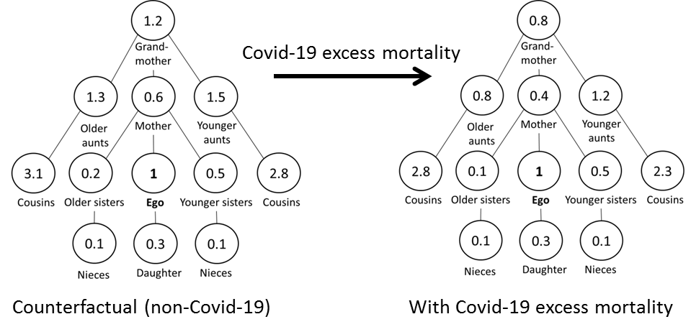

Fig 1. Expected number of relatives for an average woman in a world without Covid-19 (left) and in a world with Covid-19 (right, hypothetical female population). The excess bereavement is the sum of the difference between the expected values in each diagram.

**Work plan**

Stage 1. Formal Development

1. Derive mathematical equations to estimate excess bereavement, implement them in the R language, and wrap-up functions in an open-source package (library)
2. Estimate excess bereavement for an initial set of countries with high-quality data
3. Conduct extensive sensibility and robustness checks to validate the results, including hundreds of counterfactuals using demographic micro-simulations

Stage 2. Empirical Estimation

1. Extend estimates to other countries as more quality data becomes available
2. Write academic papers to discuss the methodology and substantive results
3. Create digital dashboard for sharing results with the public

**Expected Main Results and Achievements**

1. The first dataset of excess bereavement from Covid-19 by age and sex of the grieving population (in thousands or millions of bereaved individuals by country).
2. A flexible and scalable methodology for estimating the excess bereavement caused by Covid-19.
3. A set of academic publications in high-impact journals describing the methodology and the main results of the project
4. A online platform for scientists and policy makers to explore and download the data (see this interactive app developed by the Principal Investigator for a previous project: <https://research-app.shinyapps.io/child_death_paa/>)

**Relevance of the topic for society in light of the Corona Pandemic**

Death and bereavement have come to the forefront of public debate as the world grapples with the global pandemic of the Covid-19 disease. The pandemic has already caused the death of thousands of mainly elderly people. Each death is meaningful in itself, but it also represents the loss of a parent, grandparent, great-grandparent, aunt, uncle, cousin, or child. Studies in sociology and public health have consistently shown the negative and long-term consequences of bereavement on mental, physical, and emotional health, especially for women (Umberson et al. 2017). Bereavement also matters because relatives are crucial providers of social and financial support, the loss of which affects the individuals left behind (Hendrickson 2009). However, there are currently no estimates of the number of people who will lose a relative to the Covid-19 disease.

Information on the expected number of bereaved relatives can help policy makers develop appropriate plans for supporting the grieving relatives. Data on the age of the bereaved population is essential for targeting these programs more effectively. Young orphans may need a different type of support than widowers or elderly parents who lose a middle-aged child. The effects of bereavement are also bound to vary by levels of socio-economic development. For many people living in the Global North this will be their first close encounter with death, as historically low mortality rates have implied a reduction in the exposure to mortality at all ages in high-income countries (Alburez-Gutierrez, Kolk, and Zagheni 2019; Murphy 2011). For people in the Global South, it will add to an already high burden of bereavement (Smith-Greenaway and Trinitapoli 2020).

**Relevance of the topic for Science**

Our project will operationalize, for the first time, a set of demographic equations that can be used to estimate the expected number of surviving kin and the number of kin expected to die in the context of dramatic changes in demographic rates. We will make use of the rapid advances in computational power and parallel processing to perform complex estimations, previously thought unfeasible (Keyfitz 1985). Our interdisciplinary approach, combining demographic theory and data science, has the potential to make methodological and substantial contributions to our understanding of branching processes that have a wide application in other fields.

Substantially, the question of kin survival sits at the very center of demographic theory used for studying human and non-human populations. Historical demographers draw liberally on assumptions about kin availability and individual's exposure to the death of relatives to explain human behavior, especially in the context of rapid societal change such as epidemics, but these assumptions are often untested given data scarcity (Livi Bacci 1997; Volk and Atkinson 2013). This project will produce reliable quantitative estimates about the exposure to mortality in the context of a current pandemic. Our novel methodology can be used to understand the prevalence of bereavement in past and future global mortality crises.

**Details on collaboration**

Dr. Diego Alburez-Gutierrez will be the principal investigator and Prof. Emilio Zagheni will provide methodological supervision and assistance for project management.

**References**

Alburez-Gutierrez, D., Kolk, M., and Zagheni, E. (2019). *Women’s Experience of Child Death over the Life Course: A Global Demographic Perspective*. SocArXiv. doi:10.31235/osf.io/s69fz.

Goodman, L.A. (1974). Family Formation and the Frequency of Various Kinship Relationships. *Theoretical Population Biology*:27.

Hendrickson, K.C. (2009). Morbidity, mortality, and parental grief: A review of the literature on the relationship between the death of a child and the subsequent health of parents. *Palliative and Supportive Care* 7(1):109–119. doi:10.1017/S1478951509000133.

Keyfitz, N. (1985). *Applied Mathematical Demography*. New York: Springer. http://public.eblib.com/choice/publicfullrecord.aspx?p=3084208.

Livi Bacci, M. (1997). *A Concise History of World Population*. 2nd ed. Cambridge, MA: Blackwell.

Lotka, A.J. (1931). Orphanhood in relation to demographic factors. *Metron* 9(2):37–109.

Murphy, M. (2011). Long-Term Effects of the Demographic Transition on Family and Kinship Networks in Britain. *Population and Development Review* 37:55–80. doi:10.1111/j.1728-4457.2011.00378.x.

Smith-Greenaway, E. and Trinitapoli, J. (2020). Maternal cumulative prevalence measures of child mortality show heavy burden in sub-Saharan Africa. *Proceedings of the National Academy of Sciences*:201907343. doi:10.1073/pnas.1907343117.

Umberson, D., Olson, J.S., Crosnoe, R., Liu, H., Pudrovska, T., and Donnelly, R. (2017). Death of family members as an overlooked source of racial disadvantage in the United States. *Proceedings of the National Academy of Sciences* 114(5):915–920. doi:10.1073/pnas.1605599114.

Volk, A.A. and Atkinson, J.A. (2013). Infant and child death in the human environment of evolutionary adaptation. *Evolution and Human Behavior* 34(3):182–192. doi:10.1016/j.evolhumbehav.2012.11.007.

Zagheni, E. (2011). The Impact of the HIV/AIDS Epidemic on Kinship Resources for Orphans in Zimbabwe. *Population and Development Review* 37(4):761–783. doi:10.1111/j.1728-4457.2011.00456.x.

1. <https://dc-covid.site.ined.fr/en/>
2. <https://github.com/timriffe/covid_age>
3. <https://ourworldindata.org/coronavirus-testing>
4. <https://www.bsg.ox.ac.uk/research/publications/variation-government-responses-covid-19>
5. <https://github.com/TheEconomist/covid-19-excess-deaths-tracker>